Internal Complaint Committee / Sexual Harassment Committee
Government College Jassia (Rohtak)
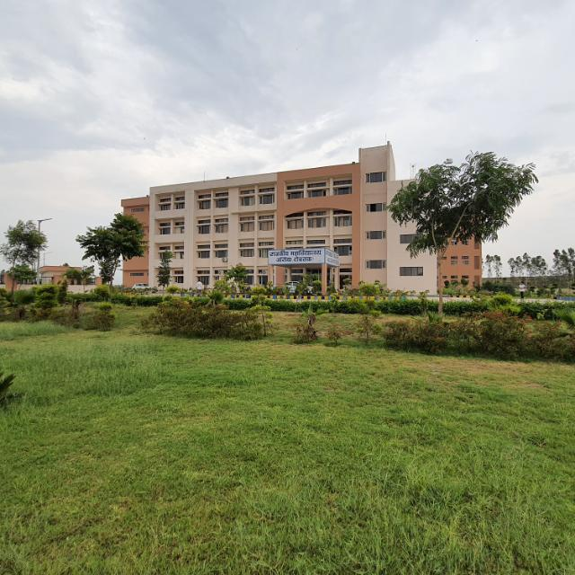 | The Internal Complaint Committee – The unsung hero of campus civility, formed under the sexual harassment of women at work place (Prevention , prohibition and redressal) Act-2013  It is not a bureaucratic ornament- It is the moral compass ensure in dignity, equality and respect thrive  Objective of ICC : - To Create safe , respectful and gender sensitive environment for all students and staff |  |  | Contact Name & Number regarding complaints:-  HOW TO COMPLAINT WITH THE CELL:-  - Personally  - Through Complaint / Suggestion Box  - Through E-mail – gcjassia1@gmail.com  - Through Head of the department / Incharge
  Dr. Meenakshi Kadian(Convenor) 9992426566
  Dr. Meenakshi Dahiya - 7988135065
  Dr. Rajkumar Siwach - 9034751717
  Dr. Satish Kumar - 9812273758
  Ms. Pushpa (PGT ExternalMember)7056587986
  Mrs. Asha Phougat (Legal Advisor)-9416310422
  Mr. Deepak (Clerk) - 7373000407
 | Mechanism of Internal Complaint Committee
 | The student/staff concerned can file the complaint personally, through teachers, through suggestion/ complaint box of through e-mail | Grievances are classified and analysed for appropriate solutions. It strives to create a campus where everyone fells secure- mentally emotionally and physically | Actions taken are communicated to the students / staff concerned. The committee ensure that complaint of sexual harassment or related misconduct are handled with fairness , confidentiality and promptness

Anti-Ragging Cell
Government College Jassia (Rohtak)
 | The Anti-Ragging Cell acts as a guardian of student safety and dignity, ensuring that college life begins with friendship and learning — not fear or humiliation.  Objective of Anti Ragging: - To Create safe , respectful and fear free environment for all students. It is responsible for implementing polices against ragging, spreading awareness and taking disciplinary action against anyone involved in ragging | Contact Name & Number regarding complaints:-  HOW TO COMPLAINT WITH THE CELL:-  - Personally  - Through Complaint / Sugesstion Box  - Through E-mail – gcjassia1@gmail.com  - Through Head of the department / Incharge
  Principal – gcjassia1@gmail.com
  Dr. Meenakshi Kadian(Convenor) 9992426566
  Dr. rajkumar Siwach 9034751717
  Dr. Shivani - 9671136767
  Mrs. Richa - 7404314006
 | Main Functions of Anti-Ragging Cell
- To prevent ragging through strict rules and awareness programs.
- To receive complaints of ragging from students.
- To investigate and take action against those found guilty.
- To ensure the psychological and emotional well-being of victims.
- To promote harmony and friendly interaction among students.

